The settings for the interface are maintained in the menu On Line System > Administration > Packsize Interface Maintenance. The settings tab currently allows you to set the import/export paths, the label temp file, and the default part number. The default part is the part that will be issued against the work order in Global Shop when the data is imported back into Global Shop from Packsize.

The import program that issues the material to the work order runs when online update processes. This will be issued to the material sequence on the work order with the part 9999001. If there is no sequence on the work order with this part number, the material will not be issued.
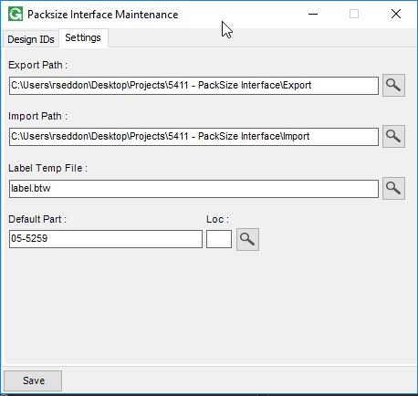

The Design IDs can be added / Maintained in the Design ID Tab. These will be available to select in the Inventory Part Packsize Data Maintenance screen.
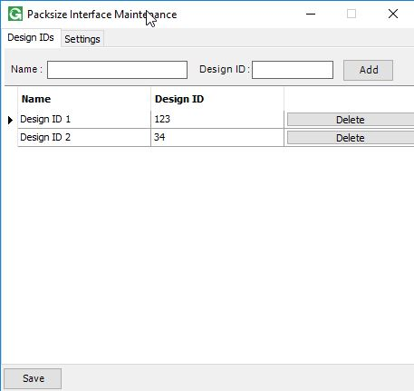

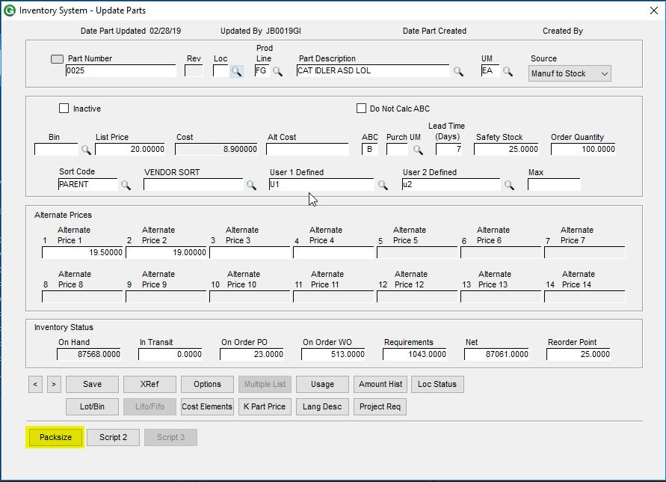
The Packsize data for each part is maintained in Inventory > File > Inventory Parts > Open, using the Script 1 button which has been renamed to Packsize.

In this menu you can set up the Packsize information for each part that will be sent to Packsize whenever a request is made.
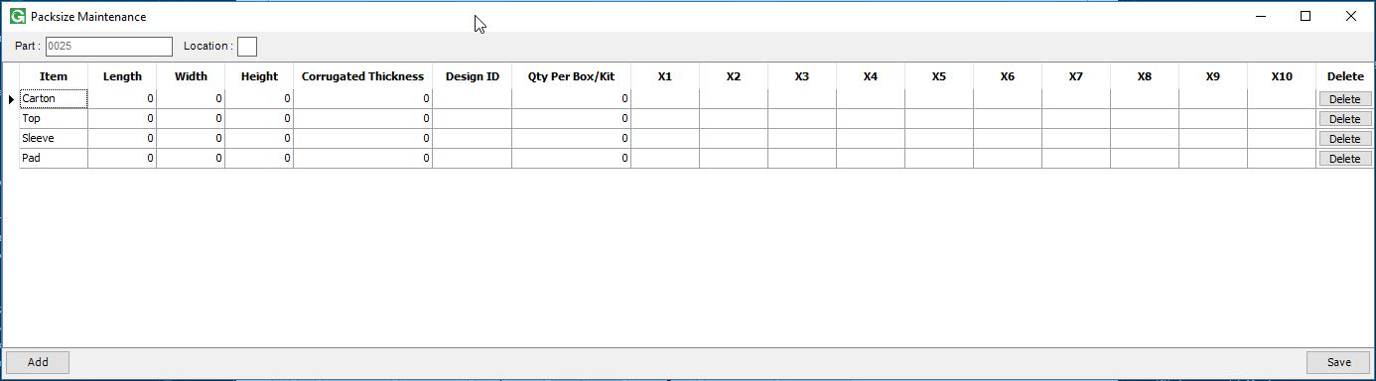

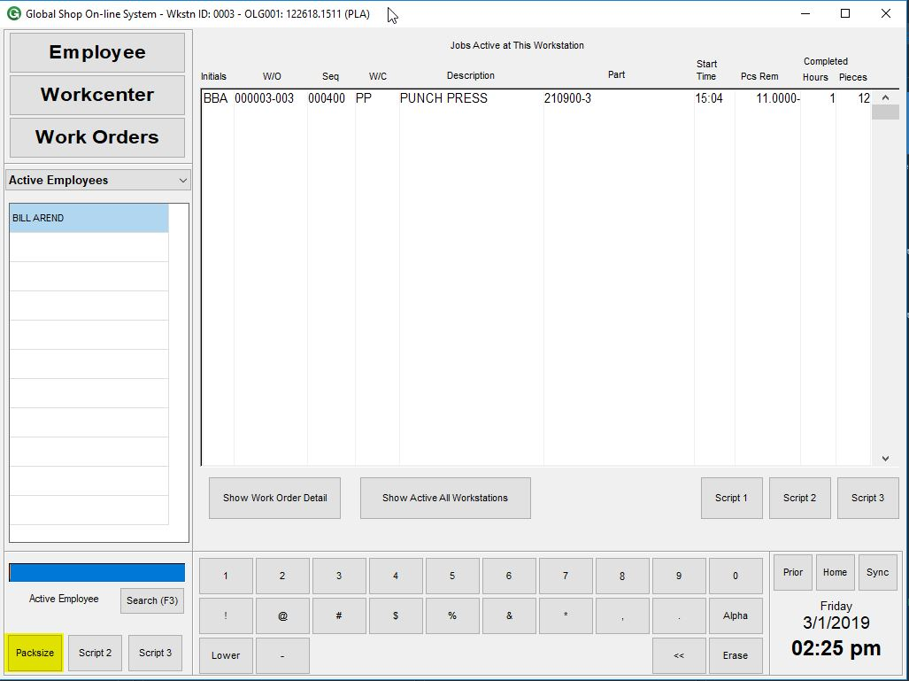
A Packsize request can now be made from the GUI Shop Floor Data Collection screen, using the Script 1 button which has been renamed to “Packsize”

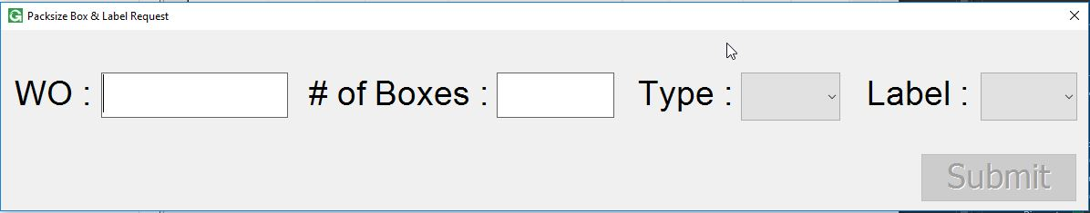
When clicked (with an Active Employee selected), the request screen will come up. Here the user needs to enter/scan in the Work Order Number (Work Order and Suffix, no divider), the number of boxes, the type, and the label. After that they can click submit and the request will be sent to Packsize. When Packsize sends a file back to Global Shop, the material used will be issued to the work order.

